**STES’s**

**SINHGAD COLLEGE OF COMMERCE, KONDHWA(Bk.)**

**NATIONAL SERVICE SCHEME**

REPORT ON “INTERNATIONAL YOGA DAY”

**Date: 21st June 2021**

As per SavitribaiPhule Pune University guidelines our college, Sinhgad College of Commerce,National Service Scheme(NSS) unit in collaboration with Vivekananda Kendra has organized online (zoom meeting)‘International Yoga Day on 21st June 2021 to bring out the importance of YOGA in our life.

The event was started at 6:00 pm with introductory speech of Mrs. SuvarnaChowdhary.

Dr. MakarandWazal, Principal , SCOC guided the students on this occasion. He told,Yoga is an ancient Indian Gift. It is the exercise for the soul and body. It is the best remedy for a better mental and physical health.It is our duty to promote this ancient gift.

Dr. Mrs. VijayaNavale, Vice Principa, SCOC, has guided the students about the importance of yoga in our modern lifestyle and in such covid-19 pandemic situation to enhance immunity and maintain good health.

After the speech of principal and vice-principal, the session was carried by Vivekananda Kendra. Yog Guru AvinashPrabhakarGokhale, Vivekananda Kendra, was the chef guest of the programme.

Firstly, Omkar Chanting was done by Ms. L.Supriya,Geet by Mr. Narendrakumar and Vivekwani by Mr. JagajeetKulkarni.

After Omkar Chanting, Geet and Vivekwani, Mrs. SuvarnaChowdhary has introduced the chef guest,Yog guru,AvinashPrabhakarGokhale.

Then after session was carried by Yog guru AvinashPrabhakarGokhale. He taught and demonstrated various yoga assanas and pranayama. He also explained the importance of yoga and pranayama. He asked everyone to practice yoga and pranayama on daily basis to get benefit of it.

Through this event, about 80 students, NSS volunteers, teaching staff, non-teaching staff and parents got benefitted.

Vote of thanks was proposed by Mr. Pramod Bora.

The programme was ended with Shanti Mantra.

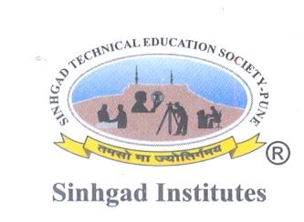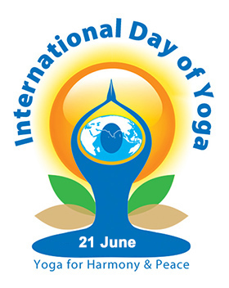

**SINHGAD INSTITUTES**

**CELEBRATES 7th INTERNATIONAL**

**YOGA DAY 2021**

**ORGANISED BY**

**SINHGAD COLLEGE OF COMMERCE,**

**KONDHWA (BK.), PUNE**

**NSS DEPARTMENT**

**ON ZOOM**

**BY**

**YOG GURU, Mr.AVINASH PRABHAKAR GOKHALE**



**Join online by Clicking following link sharp at 6:00 PM**

**<https://us04web.zoom.us/j/77086013654?pwd=bkx2QUtvdzZBNEdoUDk5VGJSTnpnUT09>**

**Meeting ID: 770 8601 3654  
Passcode: YOGA**

**SCHEDULE: MONDAY, 21st JUNE 2021**

**6.00 PM TO 7.00 PM**

**9881101868**

**8999477237**

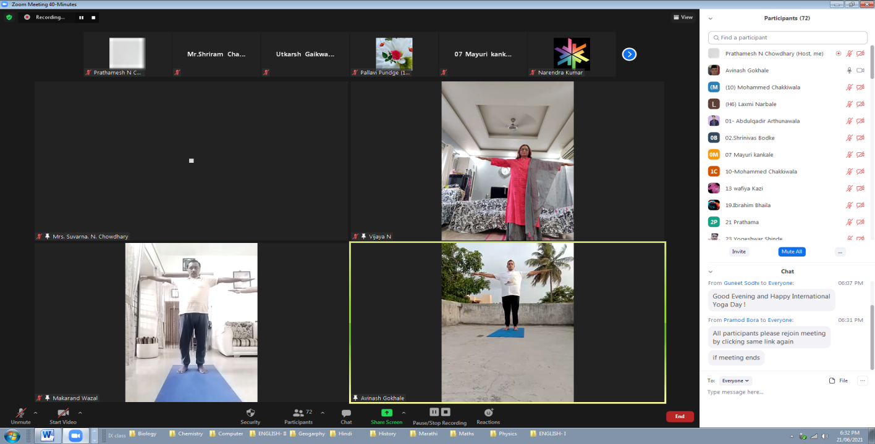

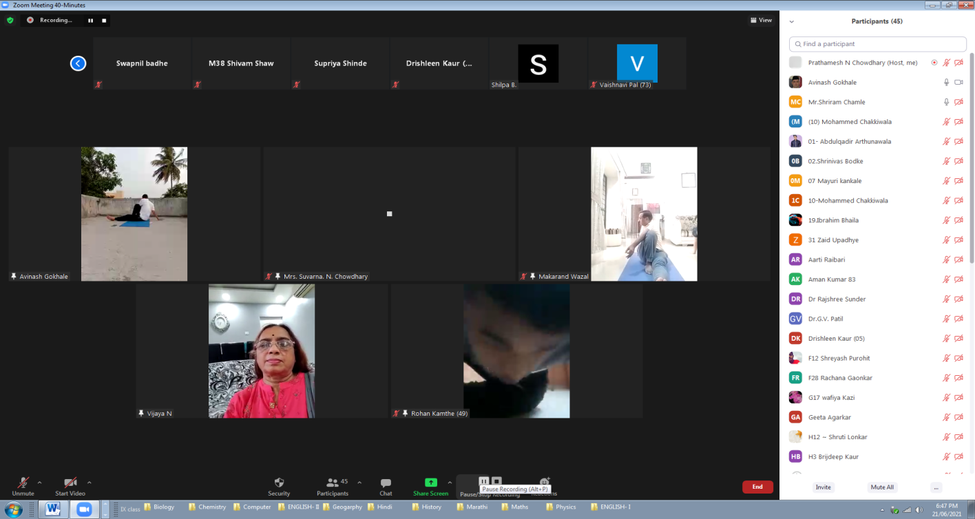

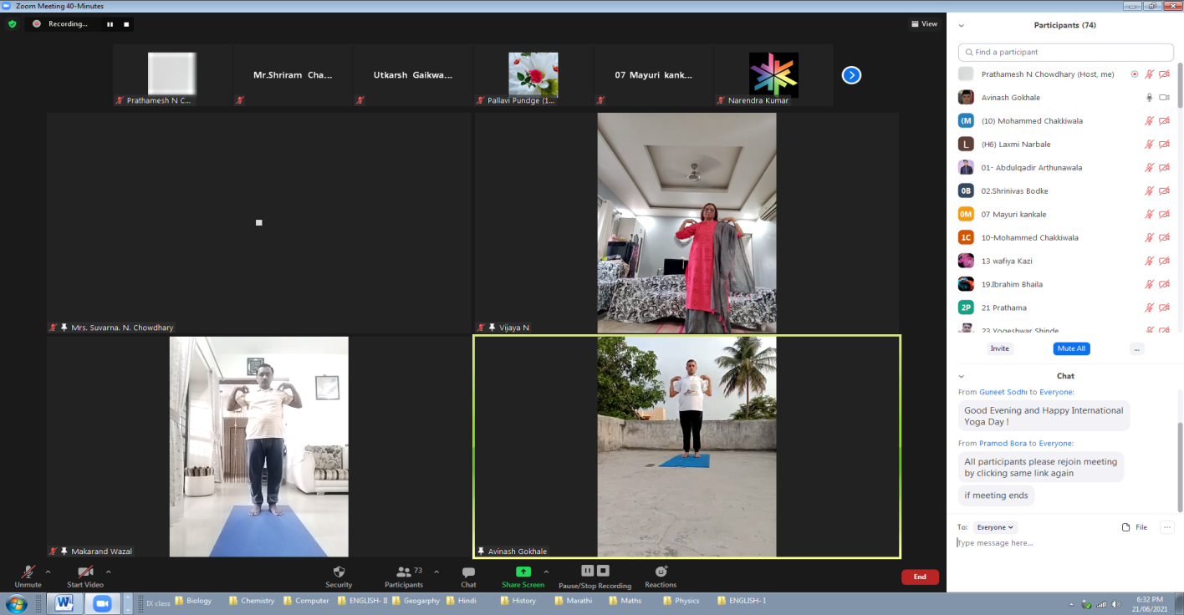

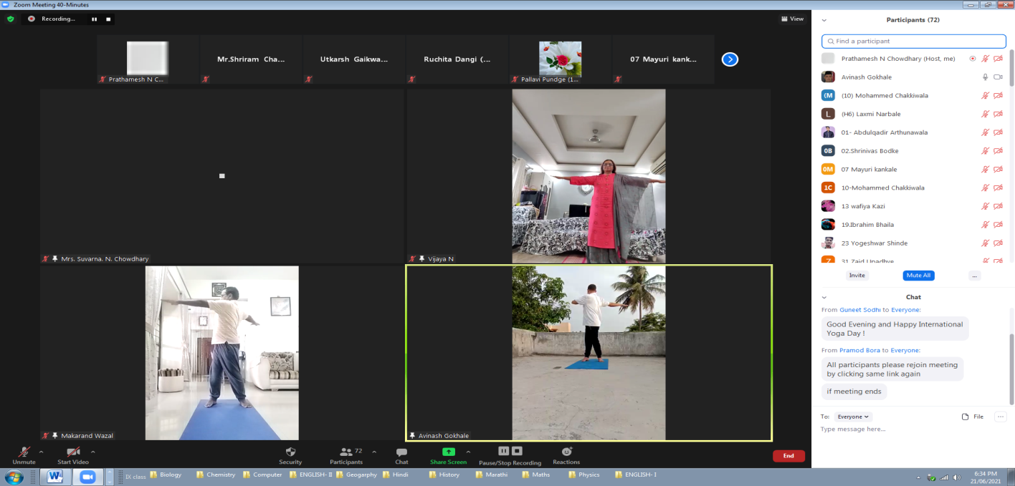

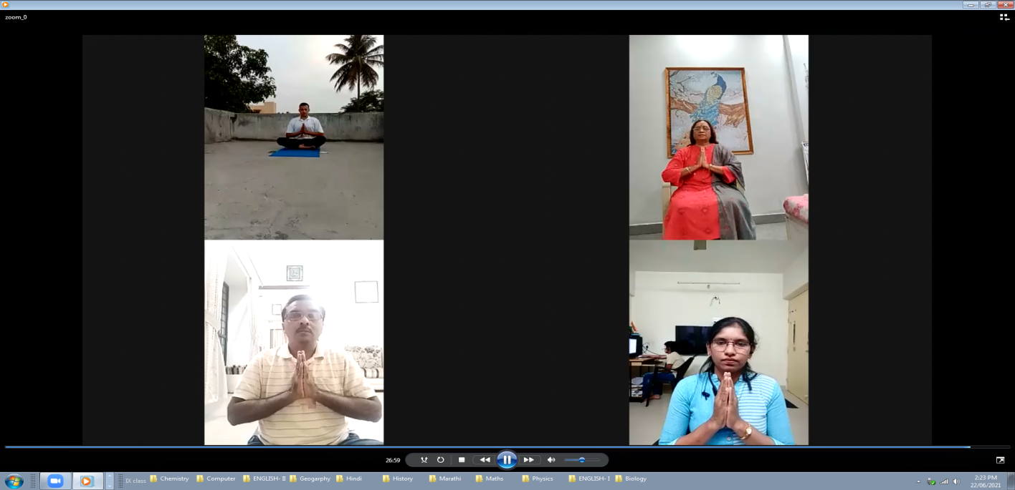

**NSS Programme Officer** **Principal**

Mrs.SuvarnaChowdhary**Dr.MakarandWazal**

Mr.Pramod Bora